Zara Sabri (F2024065491)
Software Engineering(W2)
ASSIGNMENT 2
Use Case Diagram
Types of Actors
Primary Actor
- User
A person who uses the system to register, log in, manage tasks, search tasks, view dashboard, and log out.
Secondary Actor
- Admin
A privileged user who manages users, assigns roles, generates reports, and oversees system data.
External System Actors
- Email Service API
Sends notifications, confirmations, and alerts.
- Database Server
Stores user data, task data, and reports.

List of Use Cases (Functional Requirements)
Use Case ID | Use Case Name
UC01 | User Registration
UC02 | User Login
UC03 | Task Management
UC04 | Generate Report
UC05 | Send Notifications
UC06 | View Dashboard
UC07 | Admin Role Management
UC08 | Search Tasks
UC09 | Logout

Use Case Specification Tables
Use Case 1: User Registration
Field | Details
Use Case Name | User Registration
Use Case ID | UC01
Primary Actor | User
Secondary Actors | Email Service API, Database Server
Preconditions | User is not logged in
Postconditions | User account is created and stored
Main Flow | 1. User clicks Register 2. User enters email & password 3. System validates input 4. System stores data in database 5. Confirmation email is sent
Alternate Flows | – Invalid email → error message – Email already exists → error
Extensions | N/A
Special Requirements | Passwords must be hashed and secured
Use Case 2: User Login
Field | Details
Use Case Name | User Login
Use Case ID | UC02
Primary Actor | User
Preconditions | User must be registered
Postconditions | User is logged in
Main Flow | 1. User enters credentials 2. System validates credentials 3. User redirected to dashboard
Alternate Flows | Invalid credentials → error
Special Requirements | Secure authentication
Use Case 3: Task Management
Field | Details
Use Case Name | Task Management
Use Case ID | UC03
Primary Actor | User
Secondary Actor | Admin
Preconditions | User/Admin logged in
Postconditions | Task created/updated/deleted
Main Flow | 1. Actor selects task option 2. System processes request 3. Task stored in database
Alternate Flows | Missing details → error
Special Requirements | Real-time updates
Use Case 4: Generate Report
Field | Details
Use Case Name | Generate Report
Use Case ID | UC04
Primary Actor | Admin
Preconditions | Admin logged in
Postconditions | Report generated
Main Flow | 1. Admin selects report type 2. System retrieves data 3. Report generated
Alternate Flows | No data available
Special Requirements | Export to PDF/Excel
Use Case 5: Send Notifications
Field | Details
Use Case Name | Send Notifications
Use Case ID | UC05
Primary Actor | System
Secondary Actor | Email Service API
Preconditions | Event triggered
Postconditions | Notification delivered
Main Flow | 1. System triggers event 2. Email API sends message
Alternate Flows | API failure → retry
Special Requirements | Reliable delivery
Use Case 6: View Dashboard
Field | Details
Use Case Name | View Dashboard
Use Case ID | UC06
Primary Actor | User
Preconditions | User logged in
Postconditions | Dashboard displayed
Main Flow | 1. User opens dashboard 2. System displays data
Special Requirements | Fast load time
Use Case 7: Admin Role Management
Field | Details
Use Case Name | Admin Role Management
Use Case ID | UC07
Primary Actor | Admin
Preconditions | Admin logged in
Postconditions | Roles updated
Main Flow | 1. Admin selects user 2. Assigns role 3. System saves changes
Special Requirements | Role-based access control
Use Case 8: Search Tasks
Field | Details
Use Case Name | Search Tasks
Use Case ID | UC08
Primary Actor | User, Admin
Preconditions | Logged in
Postconditions | Search results shown
Main Flow | 1. Enter search filters 2. System displays results
Special Requirements | Accurate filtering
Use Case 9: Logout
Field | Details
Use Case Name | Logout
Use Case ID | UC09
Primary Actor | User
Preconditions | User logged in
Postconditions | Session terminated
Main Flow | 1. User clicks logout 2. System ends session
Special Requirements | Secure session handling

UML Use Case Diagram
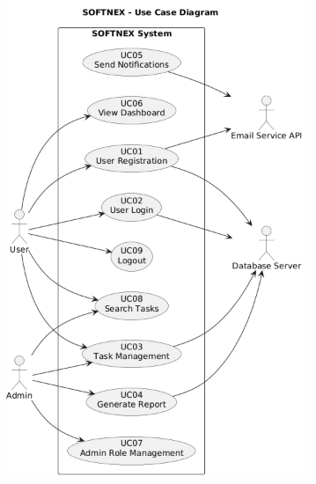

Assignment 2 Deliverable 2
PROTOTYPES

